# 7.7 Build a Navigation User Interface

A tab control is a useful tool for organizing information on the form because it can be used to separate information into tab “panes” of which only one is visible at a time, but each tab's data is still loaded and only hidden behind other tabs on the form.  Using the new navigation control first available in Access 2010 appears to be very similar to tab controls, but each tab on the navigation control will load and unload the form associated with the tab when it is selected.  This triggers record updates and re-queries the data source when the tab is opened or closed by the user.  These new navigation controls were modeled on many web sites which have top level navigation controls along the top or along the side of the web page.

In this example, we will add a simple navigation control to Kelsey Vets which opens other forms we have already developed:

1. We will create a navigation form using the Navigation Form Tool in the forms group in the Create ribbon. The Navigation Tool will create a form with tabs along the top or along the top and sides which can be linked to other forms we have already created. We will select a simple layout with one row of horizontal tabs which will be used to open the forms as follows:  
   • Navigation Tab 1: frmCustomer  
   • Navigation Tab 2: frmPets  
   • Navigation Tab 3: frmVisits
2. Open the Kelsey Vets database and click on the Create Tab.
3. Click on the **Navigation** tool from the **Forms** grouping on the Create ribbon and select **Horizontal Tabs**.
4. A Navigation Form opens where existing forms and/or reports can be dragged and dropped onto the **(Add New)** tabs.  Drag the **frmCustomers** form over and drop it on the first tab.
5. Repeat the drag and drop procedure placing the **frmPets** and the **frmVisits** on subsequent **(Add New)** tabs.
6. View the navigation form in form view. Switching from one tab to the next will now unload the current form and load the next form along with the accompanying data.
7. If you switch your Navigation Form back to Design View, it is also possible to modify the tabs themselves by first selecting one of the tabs and then going to the **Control Formatting** group on the **Forma**t ribbon. You can change the colour, shape, or the style of the selected tab(s) with the various options available.
8. It is also possible to create a navigation form with tabs and sub-tabs running on a second row horizontally below the first row, or with sub-tabs running vertically down the side. Once a first row tab is selected, the related second row or side tabs are displayed as well. You may also wish to experiment with those options.
9. Once you have created an appropriate Navigation user interface, you may wish to limit with what the users can interact. This can be done by opening the **File** menu **Options** and selecting **Current Database** to set the **frmNavigation** form as the **Display Form** and removing the **Display Navigation Pane** check box to prevent the default navigation pane from being displayed.
10. After the database is closed and reopened, only your Navigation form will be displayed for the users to interact with.  The navigation pane will no longer be available on the left side of the Access window.
11. Before you continue, go back to the **File** menu **Option**s and select **Current Database** to add a checkmark in the **Display Navigation Pane** check box so that the default navigation pane will be displayed again. You may need to close and reopen the database to once again see the navigation pane. Rather than removing the navigation pane completely we will next look at how to modify it.

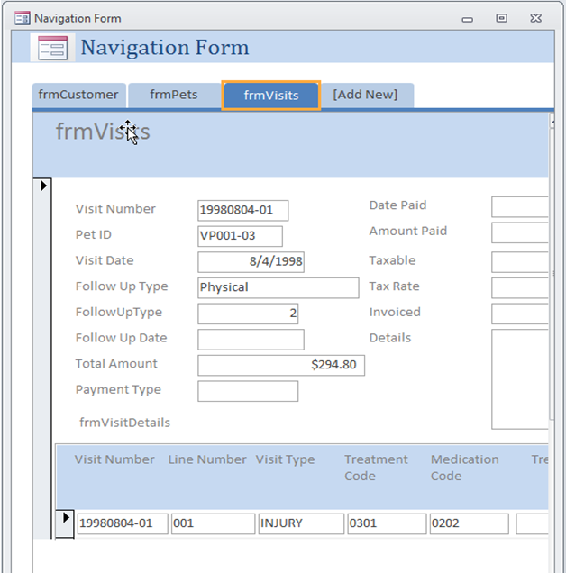

## Customizing and Locking the Navigation Pane

We can completely remove the Navigation Pane from the Access window, but it may be more desirable to customize and control the Navigation Pane which the users see.  Custom navigation can help improve efficiency by grouping, highlighting, or hiding objects.

Located along the side of the screen, the Navigation Pane provides an interface for the objects in your database, and provides several features that help you to customize the user experience.

1. In the Navigation Pane, items are arranged into groups. You choose how to group the items by specifying a category, such as **Object Type** or **Created Date**.  You can also create custom categories, and custom groups within those categories. In the custom groups, you can then create shortcuts that point to database objects.  For example, suppose you have many reports in your database, and that you run the reports with varying frequencies, such as daily or quarterly. You might create a Reports category, and then create Daily, Weekly, Monthly, Quarterly, and Yearly groups. In each group, you could then create shortcuts to the appropriate reports.
2. Shortcuts in the Navigation Pane have a **Disable Design View shortcuts** property that you can set. Right-click the shortcut, click either **Object Properties** or (for a table) **Table Properties** on the shortcut menu, and then select the **Disable Design View shortcuts** check box. If this property is enabled, the shortcut cannot be used to open its target object in Design view or Layout view. For example, if you enable this property for a shortcut to a form, users cannot change the design or layout of the form by using the shortcut.
3. The built-in categories and groups in the Navigation Pane do not display shortcuts, but instead display actual database objects. These groups include:
   * All groups in any built-in category.
   * The **Unassigned Objects** group of any custom category.

Database objects do not have a **Disable Design View shortcuts** property, however you can hide the actual database objects to help prevent design changes, and then provide shortcuts to them in custom categories and groups.

1. Much of this can be done by opening the **File** menu **Options** and selecting **Current Database.** You can then use the Navigation Options dialog box to customize the Navigation Pane.
2. The process follows these broad steps:
   * **Create a Custom Category:** Access provides one pre-built custom category for you called **Custom Groups**. You can rename that category and add or remove groups to suit your needs. You can also create new custom categories.
   * **Create a Custom Group:** After you create a category, you create one or more custom groups for the new category.
   * **Assign objects to the custom group by creating shortcuts:** In the Navigation Pane, you drag or copy and paste the database objects that you want to assign to your custom group. You drag or copy the objects from a special group in your new category called **Unassigned Objects**, which Access creates for you whenever you create a custom category.

**Notes:**

* + When you add a database object from the **Unassigned Objects** group to your custom group, Access creates a shortcut to that object — you are not moving or copying the object itself.
  + If you rename or delete a shortcut in a custom group, those changes do not affect the actual object, only the shortcut to it.
  + You can create as many shortcuts to a database object as you want but each group should have only one shortcut to a given database object.

1. **Show or hide groups or objects in a custom category:** After you populate your custom group or groups, you can hide the **Unassigned Objects** group and any other groups that you don't want to display. You can also hide individual objects.
2. In the Navigation Options dialog box add a new Custom Category and name it **KelseyVet Category**. With the KelseyVet Category selected, create 4 new Custom Groups and name them: **Vet Tables, Vet Forms, Vet Reports and Vet Queries**. Save your changes by clicking **OK** to close the Navigation Options dialog box.

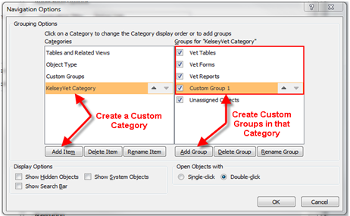

1. Before closing the Access Options dialog box, make sure that the Display Navigation Pane check box is checked.  (We might still have it turned off from the last section.)



1. Click on **OK** to close the Access Options dialog box. You may now need to close and reopen the Kelsey Vets database in order to see your changes.  When the database has been reopened, open the Navigation Pane options and select the KelseyVet Category to be displayed along with Show All. Remove the check marks from any other options.
2. Drag and drop objects from the Unassigned Objects group to the appropriate KelseyVet group in the Navigation Pane - to either the Vet Tables, Forms, Reports or Queries group. Note that the icon now indicates that the new object is actually a shortcut (or pointer) to the original object rather than the object itself.
3. It is now possible to prevent users from modifying forms, queries or reports by disabling design view shortcuts. Right mouse click on the object, open the shortcut properties and check the attributes to hide the form and/or disable design view shortcuts. Hiding a form might be appropriate for a subform which is intended to only be opened inside a main form such as **frmVisitsSubForm** for example. More frequently you may wish to prevent users from modifying your design of the forms and reports.
4. You can hide some or all of the groups in a custom category and some or all of the objects in a group.
   * Access provides two ways to hide items. You can use commands that are provided by the Navigation Pane to hide a shortcut in a group, or you can set a database object's **Hidden** property to hide shortcuts to the object in all the groups and categories in the open database, including built-in categories and groups.
   * You can make hidden objects and groups completely invisible, or you can display them in the Navigation Pane as dimmed, unavailable icons. You do this by selecting or clearing the **Show Hidden Objects** check box in the **Navigation Options** dialog box. You also use that check box when you need to unhide, or restore, a group or an object.

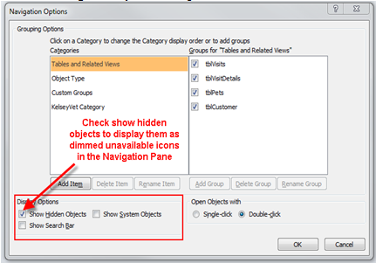

* + To hide a group in a category in the Navigation Pane, right-click the title bar of the group that you want to hide, and then click **Hide**.

#### To restore a hidden group to a category

* + 1. Right-click the menu bar at the top of the Navigation Pane and then click **Navigation Options** on the shortcut menu.
    2. In the **Categories** list, select the category that contains the hidden group.
    3. In the **Groups for "**category**"** list, select the check box next to the hidden group.
    4. Click **OK**.
  + To restore a hidden shortcut you can check the Show Hidden Objects display option in the Navigation Options, then you can right mouse click on the greyed out shortcut and uncheck the attributes to hide and/or allow design changes.

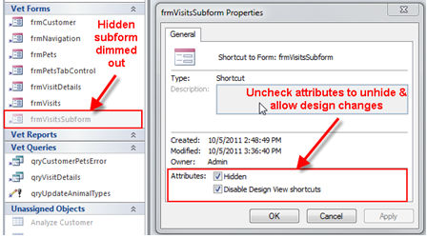

## Control the Navigation Pane by using a macro:

Access provides several macro actions that you can use to control the Navigation Pane. You can use a macro action to do any of the following:

* + Selectively show or hide categories
  + Lock the Navigation Pane to help prevent accidental changes
  + Navigate to a category or group
  + Hide the Navigation Pane

These actions can be used at any time. You can add them to an existing macro or create a new macro for them. To run macro actions automatically when a database opens, put the actions in a macro named **autoexec**.

In general, if you decide to work with macros, keep the following in mind:

**Usability features can be bypassed.**

* + If you use a macro to control and lock the Navigation Pane, remember that users can disable the macro at startup by pressing and holding the SHIFT key.
  + Although Navigation Pane shortcuts have a **Disable Design View shortcuts** property, database objects themselves do not. You can hide the categories and groups that contain database objects and you can hide the objects themselves, but it is possible for users to unhide them.

**Focus on the user.**

* + When you plan and design the navigation system for a database, work with the people who will use it. If it is not practical to work with the specific people who will use a database, keep their needs central to your design process.

**Security is not the goal.**

* + Your goal in implementing these features to control the Navigation Pane should be to improve the usability of a database. These features are not designed to help secure a database.

## Add Command Buttons

To add command buttons that open the Treatments and Medications forms from a Maintenance form complete the following steps:

1. Create forms for tblTreatment and tblMedications using the Form Wizard tool after selecting the appropriate table.
2. Save the two forms as frmTreatment and frmMedications.
3. Open a new blank form in Design View.
4. Select the Use Control Wizards button from the Controls group on the Design ribbon.  (You will need to expand the Controls group using the pull down on the right side.)
5. Click on the “Button” tool and draw a button on the new form grid.
6. The first Command Button Wizard window is opened and displays two list boxes. The first list box displays the Categories of actions while the second list box displays specific Actions associated with each category. Select the Form Operations category in the first list box to display the list of available Form Actions in the second list box.
7. Click on the Open Form action in the second list box and click Next.
8. Select the frmMedications from the list box objects to open and click Next.
9. Accept the default display Open the form and show all records. Click Next.
10. Click on the radio button adjacent to the text option and type in Open Medications Form. Click Next.
11. Change the command button name to cmdOpenMedicationsForm. Click Finish.
12. Repeat the Steps 6-11 to add a button that will open the Treatments form.
13. Repeat the Steps 6-11 to add a button that will close the Maintenance form.
14. If you have to resize the form: Change the Maintenance Form:
15. Properties:
    1. Caption: Maintenance Form
    2. Pop Up: Yes
    3. Modal: Yes
    4. Border Style: Dialog
    5. Record Selectors: No
    6. Navigation Buttons: No
    7. Scroll Bars: Neither
    8. Open the form, and resize the window. Close and save the form with the new size
16. View and test the completed Maintenance form.
17. It is also possible to change the style, shape and colour of the **Control Button** using the various options in the **Control Formatting** group on the **Forma**t ribbon of the **Form Design Tools**.

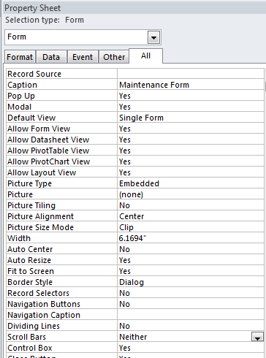

# Additional Form Controls

## Toggle Button

The toggle button communicates a yes/no, true/false, on/off state to the user. Often this is used to set an option that is either enable or disabled, but it can be bound to a Yes/No field in a similar way as a check box.

* Add a new Yes/No field to tblCustomer called CurrentCustomer
* Go into datasheet view and change some of the values manually to Yes
* Create a form based on the tblCustomer table using the form wizard, add all Customer fields
* Remove the layout from the controls
* Change the checkbox for CurrentCustomer to a toggle button and resize it to an appropriate size as needed
* Test the form to see how the toggle button looks and behaves based on the Yes/No values
* Save the form as frmCustomerControls

## Option Group

An option group stores a numeric value that selected from several radio (option) buttons. Unlike a combo box or list box, it is not dynamic (no row source), so it isn’t suitable for lists of data that will change. It can be bound to an integer field for a control source.

* Modify frmCustomerControls in Design View
* Remove the Type of Customer label and text box controls from the form
* Use the control wizard to create an option group control. If the wizard does not appear make sure it is enabled.
* Set the label values for display to Type 1, Type 2, Type 3
* Select a default choice of Type 1
* Leave the values for each option set to 1, 2, and 3
* Choose to store the value in the Type of Customer field
* Finish the wizard
* Open the form in Form View and observe the result
* Modify the tab order to ensure both the option group and the toggle button have an appropriate place in the tab order for the form